1.Create a luxurycar object and displa its complete rental information.
import java.util.Scanner;
class Vehicle{
String regNo;
double rentalRate;
Vehicle(String regNo,double rentalRate){
this.regNo=regNo;
this.rentalRate=rentalRate;
}
void displayDetails(){
System.out.println("Registration Number:"+regNo);
System.out.println("Rental Rate:"+rentalRate);
}
}
class Car extends Vehicle{
int seats;
Car(String regNo,double rentalRate,int seats){
super(regNo,rentalRate);
this.seats=seats;
}
void displayDetails(){
super.displayDetails();
System.out.println("Number of seats:" +seats);
}
}
class Luxurycar extends Car{
double chauffeurfee;
Luxurycar(String regNo,double rentalRate,int seats,double chauffeurfee){
super(regNo,rentalRate,seats);
this.chauffeurfee=chauffeurfee;
}
void displayDetails(){
super.displayDetails();
System.out.println("chauffeurfee fee:"+chauffeurfee);
System.out.println("Total Rental Cost:"+(rentalRate+chauffeurfee));
}
}
public class Vehicles{
public static void main(String[]args){
Scanner sc=new Scanner(System.in);
System.out.println("Enter Registration No:");
String regNo=sc.nextLine();
System.out.println("Enter Rental Rate:");
double rentalRate=sc.nextDouble();
System.out.println("Enter Number of seats:");
int seats=sc.nextInt();
System.out.println("Enter chauffeurfee:");
double chauffeurfee=sc.nextDouble();
Luxurycar obj=new Luxurycar(regNo,rentalRate,seats,chauffeurfee);
System.out.println("\n Vehicle Details:");
obj.displayDetails();
sc.close();
}
}
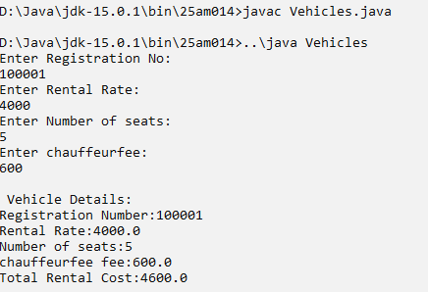
OUTPUT:

2.Calculate salary() inside each subclass’s salary calculation method to reuse the base salary logic.
import java.util.Scanner;
class Employee {
String name;
int empId;
double basicSalary;

Employee(String name, int empId, double basicSalary) {
this.name = name;
this.empId = empId;
this.basicSalary = basicSalary;
}
double calculateSalary() {
return basicSalary;
}
}
class Teacher extends Employee {
String subject;
double allowance;
Teacher(String name, int empId, double basicSalary,
String subject, double allowance) {

super(name, empId, basicSalary);
this.subject = subject;
this.allowance = allowance;
}
double calculateSalary() {
return super.calculateSalary() + allowance;
}
void display() {
System.out.println("\nTeacher Details");
System.out.println("Name : " + name);
System.out.println("ID : " + empId);
System.out.println("Subject : " + subject);
System.out.println("Total Salary : " + calculateSalary());
}
}
class NonTeachingStaff extends Employee {
String department;
String shift;
NonTeachingStaff(String name, int empId, double basicSalary,
String department, String shift) {
super(name, empId, basicSalary);
this.department = department;
this.shift = shift;
}
double calculateSalary() {
return super.calculateSalary() + 2000;
}
void display() {
System.out.println("\nNon-Teaching Staff Details");
System.out.println("Name : " + name);
System.out.println("ID : " + empId);
System.out.println("Department : " + department);
System.out.println("Shift : " + shift);
System.out.println("Total Salary : " + calculateSalary());
}
}
public class Emp {
public static void main(String[] args) {
Scanner sc = new Scanner(System.in);
System.out.println("Enter Teacher Details");
System.out.print("Name: ");
String tName = sc.nextLine();
System.out.print("Employee ID: ");
int tId = sc.nextInt();
System.out.print("Basic Salary: ");
double tSalary = sc.nextDouble();
sc.nextLine();
System.out.print("Subject: ");
String subject = sc.nextLine();
System.out.print("Allowance: ");
double allowance = sc.nextDouble();
sc.nextLine();
Teacher t = new Teacher(tName, tId, tSalary, subject, allowance);
System.out.println("\nEnter Non-Teaching Staff Details");
System.out.print("Name: ");
String nName = sc.nextLine();

System.out.print("Employee ID: ");
int nId = sc.nextInt();
System.out.print("Basic Salary: ");
double nSalary = sc.nextDouble();
sc.nextLine();
System.out.print("Department: ");
String dept = sc.nextLine();
System.out.print("Shift Timing: ");
String shift = sc.nextLine();
NonTeachingStaff n = new NonTeachingStaff(nName, nId, nSalary, dept, shift);
t.display();
n.display();
sc.close();
}
}
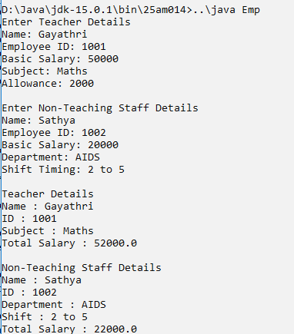
OUTPUT:

